# Matthew Richards (ID: 38813858) – Block 5 Report – Front-End Development

Contents

Matthew Richards (ID: 38813858) – Block 5 Report – Front-End Development 1

Introduction 1

The Web Technologies 2

Accessibility 3

Documenting Website 9

Deploying the Website 15

Requirements Engineering 16

Conclusion 18

References 18

## Introduction

The purpose of this project is to produce a functioning website for an online phone shop to promote and sell products. Included, are a minimum of 4 pages linked together adhering to interface design standards. A form is included to collect customer information, adhering to privacy and data protection standards, as well as an order cart to give customers the ability to total the collective items, add and remove items and an option to place an order. To ensure this was achieved, HTML, CSS, Bootstrap and JS were used throughout. The website is hosting at the following GitHub address. (https://taylormadematt88.github.io/UA92-Block-5/).

## The Web Technologies

The structure of all four required web pages is written using HTML (HyperText Markup Language). Each page consists of several elements, repeated on every page of the website to maintain coherency in terms of design, which is aesthetically pleasing to users (Kittle, 2021). A ‘head’ tag is used to hold the unique title of each page, meta tags and stylesheets. Having a clearly defined section makes it easier and faster for the user to find this information if searching for an external font source that is used or the pathway of the CSS (Cascading Style Sheets) stylesheet for example (W3C, 2022). The ‘body’ tag stores the main elements of the website in concurrent order. A logo sits a top of the page, using an ‘img’ tag in the HTML. It is placed centrally to draw the user’s attention to the central flow of the website.

To navigate between each four of the pages, a navigation bar was implemented using an unordered list (‘ul’ tag). Within the list an anchor tag was used (‘a href’) for the internal hyperlinks. Having an easy-to-read navigation bar, repeated on each page, helps a user navigate the site (W3Schools, 2022a).

A separate CSS file is used to stylise the layout of all four pages. Having a separate CSS stylesheet, rather than using an HTML inline style, gives the developer greater control over all elements on the site as well as making any changes more efficient as they only need to amend the CSS stylesheet instead of several lines in the HTML (W3C, 2022).

In an addition to an ecommerce feature, a separate form was integrated on the contact us page using JavaScript. A ‘validateform’ function is used with five variables for the customers first name, last name, email, phone number and message fields. A ‘If’/else if’ statement is used to ensure that each field is filled out correctly with the name categories requiring text, the email field asking for an @ symbol and the phone field set as a number input. This is used to make sure that the site is only gathering relevant information, displaying an alert to prompt the user if the input returned is false. The form adheres to data protection standards, only requesting relevant information (W3C, 2019a).

One of the key features of the site is its responsive nature across a range of devices. To achieve this, a CSS framework (Bootstrap 5) was used. Column, image and font scale appropriately when the browser window is condensed or expanded. The use of Bootstrap was essential to maintain usability whether on desktop or mobile and does this on a wide selection of browsers (Ouellette, 2016).

## Accessibility

Web accessibility ensures that websites are designed in a way that users with disabilities can understand and navigate easily. It is important for inclusivity, helping people have equal access to information, technology and opportunities. World Wide Web Consortium (W3C) set these international standards across all web pages (W3C, 2019b).

To ensure industry standards were met, the site was compared to the A11Y Project’s checklist (<https://www.a11yproject.com/checklist/>). Recommended by W3C, this is a thorough and reliable tool (W3C, 2016). The following examples show the results of this.

Figure 1 – A11YProject Checklist

The ‘HTML lang’ tag is set to English and sits above the head tag on each page of the website. This is important as it helps assistive techology to pronounce content correctly (Indiana University, 2022).

A unique title has also been set for each of the four pages on the website to inform the user what page they are on to aid with site navigation. Having the website’s title inside the ‘head’ tag on each individual page maintains consistency in the code.

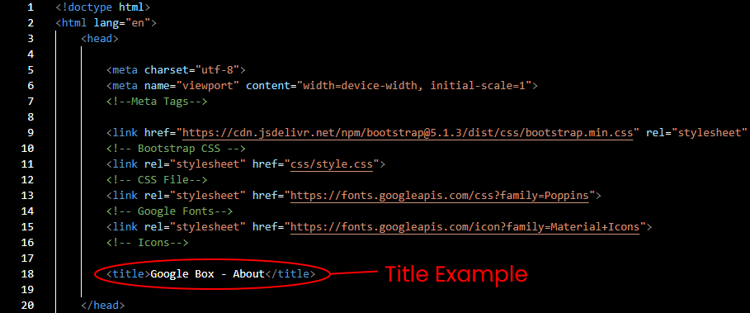

Figure 2 - Img & Alt Tag Requirements

An ‘alt’ tag is included on each image, providing a description for a screen reader user. As previoiusly mentioned, this is important for inclusivity for assisted digital users.

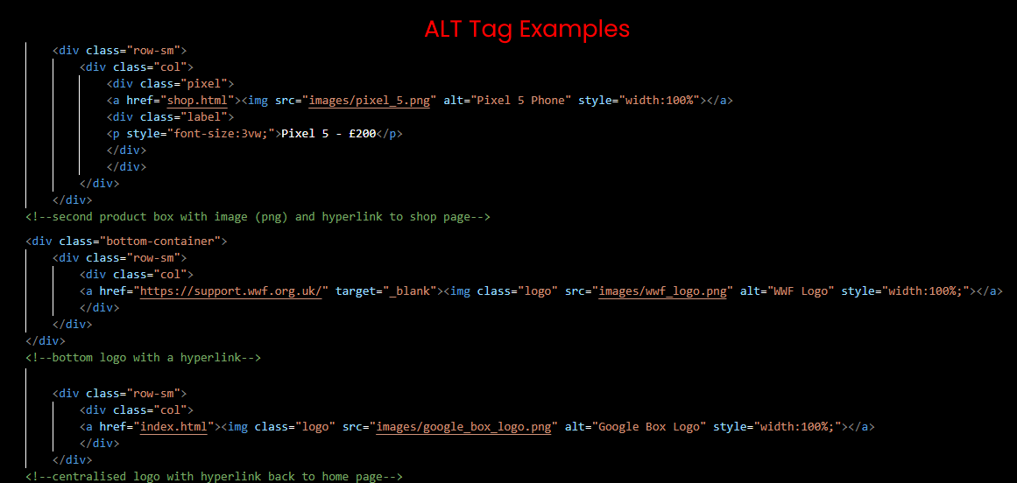

Figure 3 – Heading Requirements

Headings follow a sequential order, for example H1,H2 H3, etc, across all pages of the site. This maintains an order to the text appearing on each page.

Figure 4 – List Structure

Finally, a ‘ul’ tag is used for the website’s navigation bar. This helps establish the overall structure of the page, with the placement always at the top of each page (Initiative (WAI), 2022). It also informs the user that the list is unordered and as such each tab can be selected in any order.

## Documenting Website

In this section I will discuss and document the key features of my website. I will explain design choices, expand on the use of a form and how an ecommerce feature was implemented.

Design Choices

When deciding on the design of my website I opted to have a core concept that would dictate the design and layout choices. Focusing on selling Google products led to the use of a Google Font (Poppins) across the site.

Example of website’s font

This also helped me decide on a minimalistic style emulating the Google store with large, easy to read text (Google, 2022). I also incorporated this into the logo’s design.

Website Logo

After determining the product choice, I developed a company ethos focusing on refurbished phones, encouraging a responsible approach to phone use. This influenced a lot of the language on the site including the use of a banner that externally links to the World Wildlife Federation with a campaign slogan of “Pixels Help Pandas”.

WWF Banner

In keeping with the environmentally responsible theme, I created a colour palette that used blues and greens to invoke an ‘Earth’ theme. Using subdued blues and greens also creates a calming palette which helps producing a pleasant UX experience (Dulux, 2022).

Before creating my four pages I drew out a flow diagram breaking down each page and what technology was used to create it. This helped me ensure that navigation was logical and gave me a resource to check the correct code was linked and used on each page. In addition to this, I also included the main logo and a banner at the bottom of the index page to plan the pathway of each (external or internal).

Another stylistic feature that was selected was the use of box shadowing on the product containers on both the index and shop page. This was chosen to draw the user’s attention to those containers, highlighting them as the most important feature on the page. The same technique was used for the form on the contact page and cart container on the shop page. This design feature was inspired by Google’s search bar when highlighted by the cursor.

Figure 5 – Example box shadow on Google search bar

Contact Form

While writing the HTML code for the form feature, I included a ‘form’ tag to structure the contact form. ‘Label’ tags were used for the name of the field while an input type was written in a separate tag (‘input’). I used ‘br’ tags to break up the flow of the form and used ‘p’ tags for additional spacing in between input boxes.

In JavaScript, I implemented the function ‘validateform’ with 5 variables. I used an ‘if/else’ statement to execute the code, each with a specific message if the input on the form did not adhere to the field’s requirements.

By giving the ‘Message’ section a ‘textarea’ tag I was able to style that section of the form in CSS, creating a larger box for text input from the user.

Shopping Cart

An ecommerce feature was used to total the products on the shop page. An ‘add to cart’ button adds the product to the cart, while the ‘updateCartTotal’ function totals the price of each item. The ‘addedToCart’ function displays a message to inform the user that an item as has been added above the product and cart containers. Finally, the ‘emptyCart’ function clears the totalled cart while the ‘checkoutNow’ function brings up a prompt asking if the user wants to confirm their purchase if ‘okay’ is selected or a message of ‘Looks like you forgot something’ if ‘cancel’ is selected.

On reflection, a separate checkout page with confirmation and the order details displayed, prompted by the selection of ‘okay’ on the ‘checkoutNow’ function, would have been the ideal end of the shopping cart experience.

To ensure no mistakes were made in my code, I passed it through a W3’s Nu Html Checker (https://validator.w3.org/nu/).

After passing the ‘index’ page through the validator there were initial errors in the syntax.

Figure 5 – Nu Html Checker – Initial Syntax Errors

The following amendments were made in the HTML to resolve the issue.

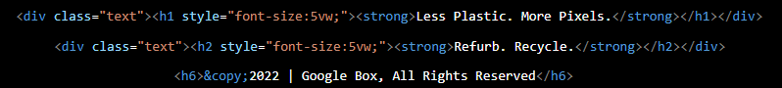

Removing the center tags in the HTML, using only CSS for aligment, gave greater control of the text placement as well as the overall placement of all the elements on the website.

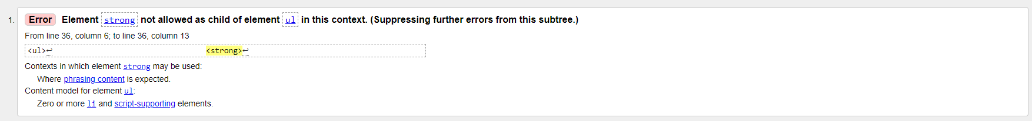

Figure 6 – Incorrect use of ‘Strong’ tags

Another change that I made was to remove the ‘strong’ tags in the HTML in the list, instead stylsing the font in my CSS.

Figure 7 – Changes made in HTML & CSS

## Deploying the Website

To host the website, a GitHub account was created to hold all relevant files in a repository.

Figure 8 – GitHub Repository

An adjustment was needed in the HTML code to change the ‘href’ link location. The website’s URL was added, and a capitalisation of CSS was needed for the page to load correctly. In future, a lower-case format for folders and files would be more efficient and adhere to good general practices.

Figure 9 – GitHub Pages

A source for the GitHub Pages was established, with the root folder used. This was done to ensure the site loaded automatically.

## Requirements Engineering

To ensure the website was created to the shop owner’s needs, requirement engineering techniques were used.

Requirement engineering is a technique to gather information from a client to ensure that all their user’s requirements are met (Java T Point, 2021). When exploring which technique was best to implement, two techniques were considered.

Brainstorming, an open discussion to generate concepts to achieve a collective goal, is one technique that was considered (Interaction Design Foundation, 2022). This is a good way to build a relationship with the client as well as making them feel part of the process. Despite these positives, there are several downsides to this approach. Although an open forum for ideas, this technique lacks a structure and can lead to too many options without an overall focus. In addition to this, brainstorming can be a time-consuming exercise with more efficient techniques available (Software Testing Help, 2022).

The second technique, and the one selected, was to produce a survey. Like brainstorming, information can be gathered but to a larger audience with far less time required (Software Testing Help, 2022). With that said, a client may not be clear on the questions posed, possibly presenting a more drawn-out process. Nevertheless, a survey was produced with open-ended and close ended questions to encourage more descriptive answers avoiding lack of clarity.

Figure 10 - Client Survey that was produced

Above is the client survey presenting several questions. The first two questions were intended to understand the identity of the company. Obtaining this information helps when choosing language and general presentation used throughout the site. The two close ended questions, those with checkbox options, were asked to determine the UX (User Experience) and UI (User Interface) design. Space to add additional comments is included to help eliminate a possible lack of clarity in the questioning.

On review, although the survey covers a wide range of topics, more questions could have been asked to gain a thorough understanding of the client’s needs.

## Conclusion

In closing, several techniques have been acquired during the role as a front-end developer, that will be taken forward.

Adhering to data privacy and accessibility standards is essential to make future projects accessible to all users. In future, ensuring a HTML language is set, ‘alt’ tags are imbedded on images and a concurrent ordering of header tags will be implemented. The use of CSS, for the styling of a website adding greater flexibility when making design adjustments to a site, and JavaScript, giving the developer greater control over the behaviour of features such as forms and shopping carts, will be crucial. Using a combination of HTML, CSS and JavaScript, to deliver the most complete experience for website design, will be an ideal process in future website design projects.

# References

* Dulux (2022). *Create A Relaxing Space With Calming Colours | Dulux*. [online] www.dulux.co.uk. Available at: https://www.dulux.co.uk/en/articles/colour-know-how-create-relaxing-space-calming-colours.
* Google (2022). *Pixel 6 Pro*. [online] Google Store. Available at: https://store.google.com/gb/product/pixel_6_pro?hl=en-GB#p6p-overview-camera [Accessed 20 May 2022].
* Indiana University (2022). *Human language markup: Web content: Creating accessible content: Accessibility: Indiana University*. [online] Accessibility. Available at: https://accessibility.iu.edu/creating-content/web-content/language-markup.html [Accessed 20 May 2022].
* Initiative (WAI), W.W.A. (2022). *Content Structure*. [online] Web Accessibility Initiative (WAI). Available at: https://www.w3.org/WAI/tutorials/page-structure/content/ [Accessed 20 May 2022].
* Interaction Design Foundation (2022). *What is Brainstorming?* [online] The Interaction Design Foundation. Available at: https://www.interaction-design.org/literature/topics/brainstorming#:~:text=Brainstorming%20is%20a%20method%20design.
* Java T Point (2021). *Software Engineering | Requirement Engineering - javatpoint*. [online] www.javatpoint.com. Available at: https://www.javatpoint.com/software-engineering-requirement-engineering.
* Kittle, B. (2021). *How to Utilize Repetition in Web Design*. [online] Clockwork Design Group, Inc. Available at: https://www.cdgi.com/2021/01/design-principle-no-4-repeat-repeat-repeat-repeat/#:~:text=In%20web%20design%2C%20repetition%20helps [Accessed 20 May 2022].
* Ouellette, A. (2016). *What Is Bootstrap: a Beginners Guide*. [online] Careerfoundry.com. Available at: https://careerfoundry.com/en/blog/web-development/what-is-bootstrap-a-beginners-guide/.
* Software Testing Help (2022). *Top 10 Most Common Requirements Elicitation Techniques*. [online] www.softwaretestinghelp.com. Available at: https://www.softwaretestinghelp.com/requirements-elicitation-techniques/.
* W3C (2016). *Web Accessibility Evaluation Tools List*. [online] W3.org. Available at: https://www.w3.org/WAI/ER/tools/.
* W3C (2019a). *Standards - W3C*. [online] W3.org. Available at: https://www.w3.org/standards/.
* W3C (2019b). *W3C Accessibility Standards Overview*. [online] Web Accessibility Initiative (WAI). Available at: https://www.w3.org/WAI/standards-guidelines/.
* W3C (2022). *HTML & CSS - W3C*. [online] www.w3.org. Available at: https://www.w3.org/standards/webdesign/htmlcss#:~:text=The%20separation%20of%20HTML%20from [Accessed 20 May 2022].
* W3Schools (2022a). *CSS Horizontal Navigation Bar*. [online] www.w3schools.com. Available at: https://www.w3schools.com/css/css_navbar_horizontal.asp.
* W3Schools (2022b). *HTML head tag*. [online] www.w3schools.com. Available at: https://www.w3schools.com/tags/tag_head.asp.